

Packet Tracer - Verify Single-Area OSPFv2

Name: Luis Enrique Pérez Señalin.

# Addressing Table

|  |  |  |  |  |
| --- | --- | --- | --- | --- |
| **Device** | **Interface** | **IP Address** | **Subnet Mask** | **Default Gateway** |
| R1 | G0/0 | 172.16.1.1 | 255.255.255.0 | N/A |
| G0/1 | 64.100.54.6 | 255.255.255.252 |
| S0/0/0 | 172.16.3.1 | 255.255.255.252 |
| S0/0/1 | 192.168.10.5 | 255.255.255.252 |
| R2 | G0/0 | 172.16.2.1 | 255.255.255.0 | N/A |
|  | S0/0/0 | 172.16.3.2 | 255.255.255.252 |  |
|  | S0/0/1 | 192.168.10.9 | 255.255.255.252 |  |
| R3 | G0/0 | 192.168.1.1 | 255.255.255.0 | N/A |
| G0/1 | 192.168.11.1 | 255.255.255.0 |
| S0/0/0 | 192.168.10.6 | 255.255.255.252 |
| S0/0/1 | 192.168.10.10 | 255.255.255.252 |
| R4 | G0/0/0 | 192.168.1.2 | 255.255.255.0 | N/A |
|  | G0/0/1 | 192.168.11.1 | 255.255.255.0 |  |
| ISP Router | NIC | 64.100.54.5 | 255.255.255.252 | N/A |
| PC1 | NIC | 172.16.1.2 | 255.255.255.0 | 172.16.1.1 |
| PC2 | NIC | 172.16.2.2 | 255.255.255.0 | 172.16.2.1 |
| PC3 | NIC | 192.168.1.2 | 255.255.255.0 | 192.168.1.1 |
| Laptop | NIC | DHCP | DHCP | DHCP |

**Objectives**

In this lab, you will use the CLI commands to verify the operation of an existing OSPFv2 network. In Part 2, you will add a new LAN to the configuration and verify connectivity.

* Identify and verify the status of OSPF neighbors.
* Determine how the routes are being learned in the network.
* Explain how the neighbor state is determined.
* Examine the settings for the OSPF process ID.
* Add a new LAN into an existing OSPF network and verify connectivity.

# Background / Scenario

You are the network administrator for a branch office of a larger organization. Your branch is adding a new wireless network into an existing branch office LAN. The existing network is configured to exchange routes using OSPFv2 in a single-area configuration. Your task is to verify the operation of the existing OSPFv2 network, before adding in the new LAN. When you are sure that the current OSPFv2 LAN is operating correctly, you will connect the new LAN and verify that OSPF routes are being propagated for the new LAN. As branch office network administrator, you have full access to the IOS on routers R3 and R4. You only have read access to the enterprise LAN routers R1 and R2, using the username **BranchAdmin**, and the password **Branch1234**.

# Instructions

**Part 1: Verify the existing OSPFv2 network operation.**

The following commands will help you find the information needed to answer the questions:

**show ip interface brief show ip route**

**show ip route ospf show ip ospf neighbor show ip protocols show ip ospf**

**show ip ospf interface**

## Step 1: Verify OSPFv2 operation.

Wait until STP has converged on the network. You can click the Packet Tracer Fast Forward Time button to speed up the process. Continue only when all link lights are green.

1. Log into router **R1** using the username **BranchAdmin** and the password **Branch1234**. Execute the **show ip route** command.

R1# **show ip route**

--- output omitted ----

Gateway of last resort is 172.16.3.2 to network 0.0.0.0 172.16.0.0/16 is variably subnetted, 5 subnets, 3 masks

C 172.16.1.0/24 is directly connected, GigabitEthernet0/0 L 172.16.1.1/32 is directly connected, GigabitEthernet0/0

O 172.16.2.0/24 [110/65] via 172.16.3.2, 00:02:18, Serial0/0/0

C 172.16.3.0/30 is directly connected, Serial0/0/0 L 172.16.3.1/32 is directly connected, Serial0/0/0

O 192.168.1.0/24 [110/65] via 192.168.10.6, 00:02:18, Serial0/0/1

192.168.10.0/24 is variably subnetted, 3 subnets, 2 masks

|  |  |  |
| --- | --- | --- |
| C | 192.168.10.4/30 | is directly connected, Serial0/0/1 |
| L | 192.168.10.5/32 | is directly connected, Serial0/0/1 |
| O | 192.168.10.8/30 | [110/128] via 172.16.3.2, 00:02:18, Serial0/0/0 |
|  |  | [110/128] via 192.168.10.6, 00:02:18, Serial0/0/1 |

O*E2 0.0.0.0/0 [110/1] via 172.16.3.2, 00:02:18, Serial0/0/0

How did router **R1** receive the default route?

**R:** R1 recived this using OSPF, this is the method O*E2 0.0.0.0/0 [110/1] via 172.16.3.2, 00:02:18, Serial0/0/0

From which router did **R1** receive the default route?

**R:** It´s the 172.16.3.2 that is the R2 route.

How can you filter the output of **show ip route** to show only the routes learned through OSPF?

**R:** Using the “show ip route ospf” command:

172.16.0.0/16 is variably subnetted, 5 subnets, 3 masks

O 172.16.2.0 [110/65] via 172.16.3.2, 00:06:59, Serial0/0/0

O 192.168.1.0 [110/65] via 192.168.10.6, 00:07:09, Serial0/0/1

192.168.10.0/24 is variably subnetted, 3 subnets, 2 masks

O 192.168.10.8 [110/128] via 172.16.3.2, 00:06:59, Serial0/0/0

[110/128] via 192.168.10.6, 00:06:59, Serial0/0/1

O*E2 0.0.0.0/0 [110/1] via 172.16.3.2, 00:06:59, Serial0/0/0

1. Execute the **show ip ospf neighbor** command on **R1**. Which routers have formed adjacencies with router **R1**?

**R:** It was the 172.16.3.2 R2 (2.2.2.2) and 192.168.10.6 R3 (3.3.3.3)

What are the router IDs and state of the routers shown in the command output?

**R:**

R2: router ID = 2.2.2.2, state = FULL.

R3: router ID = 3.3.3.3., state = FULL.

Are all of the adjacent routers shown in the output?

**R:** Yes, the adjacent routers are R2 and R3

1. Using the command prompt on **PC1**, ping the address of the **ISP Router** shown in the Address Table. Is it successful? If not, do a **clear ospf process** command on the routers and repeat the ping command.

**R:** Yes, it did successfully

## Step 2: Verify OSPFv2 operation on R2.

1. Log into router **R2** using the username **BranchAdmin** and the password **Branch1234**. Execute the **show ip route** command. Verify that routes to all the networks in the topology are shown in the routing table.

How did router R2 learn the default route to the ISP?

**R:** The output of show ip route show this: S* 0.0.0.0/0 [1/0] via 64.100.54.5, and the S* indicate that this route is Static.

1. Enter the **show ip ospf interface g0/0** on router **R2**. What type of OSPF network is attached to this interface?

**R:** The command show the next line: Process ID 10, Router ID 2.2.2.2, Network Type BROADCAST, Cost: 1, and this indicate that Broadcast is the network type.

Are OSPF hello packets being sent out this interface? Explain.

**R:** Yes by the output: “No Hellos (Passive interface)”.

1. Using the command prompt on **PC2**, ping the S0/0/1 address on router **R3**. Is it successful?

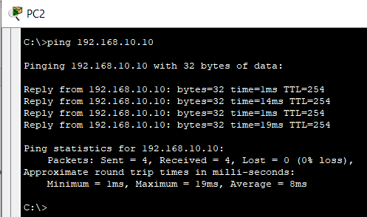R: Yes.

## Step 3: Verify OSPFv2 operation on R3.

1. Execute the **show ip protocols** command on router R3. Router R3 is routing for which networks?

R: it´s three networks:

192.168.1.0 0.0.0.255 area 0

192.168.10.4 0.0.0.3 area 0

192.168.10.8 0.0.0.3 area 0

1. Execute the **show ip ospf neighbor detail** command on router **R3**.

What is the neighbor priority shown for the OSPF neighbor routers? This value is the default.

R: Both have the same priority: 0.

Command output:

Neighbor 2.2.2.2, interface address 192.168.10.9

In the area 0 via interface Serial0/0/1

Neighbor priority is 0, State is FULL, 7 state changes

------------

Neighbor 1.1.1.1, interface address 192.168.10.5

In the area 0 via interface Serial0/0/0

Neighbor priority is 0, State is FULL, 6 state changes

1. Using the command prompt on **PC3**, ping the address of the **ISP Router** shown in the Address Table.

Is it successful?

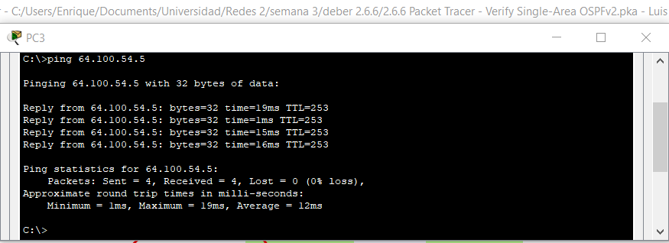R: Yes

# Part 2: Add the new Branch Office LAN to the OSPFv2 network.

You will now add the pre-configured Branch Office LAN to the OSPFv2 network.

## Step 1: Verify the OSPFv2 configuration on router R4.

Execute a **show run | begin router ospf** command on router **R4**. Verify that the network statements are present for the networks that are configured on the router.

Which interface is configured to not send OSPF update packets?

**R:** This is the g0/0/1 using this output: passive-interface GigabitEthernet0/0/1

## Step 2: Connect the Branch Office router R4 to the OSPFv2 network.

1. Using the correct Ethernet cable, connect the G0/0/0 interface on router **R4** to the G0/1 interface on switch **S3**. Use the **show ip ospf neighbor** command to verify that router **R4** is now adjacent with router **R3.**

What state is displayed for router **R3**?

**R:** Full DR

1. Using the **show ip ospf neighbor** command on **R3**, determine the state of router **R4**. There may be a delay while OSPF converges.

Why is the state of router R4 different than the state of R1 and R2?

**R:** The R3 have a direct connection with R1 and R2, but the connection with R4 is a multiple access connection.

1. Using the command prompt on Laptop, ping the address of PC2. Is it successful?

**R**: Yes, it´s

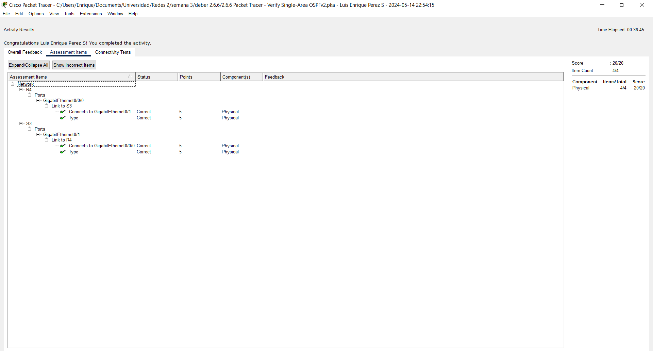

ScreenShow of excersice.